ETF Algorithm Research

**Idea: combination of DCA and Trend-following Strategies**

* [Dollar-Cost Averaging (DCA)](https://www.investopedia.com/terms/d/dollarcostaveraging.asp)
  + Basic idea: DCA is the technique of buying a certain **fixed-dollar** **amount** of an asset on a regular schedule, regardless of the **changing cost of the asset**.
* [Trend-following Strategies](https://en.wikipedia.org/wiki/Trend_following)
  + Basic idea: follow trends in [moving averages](https://www.investopedia.com/terms/m/movingaverage.asp), channel breakouts, price level movements, and related [technical indicators](https://www.investopedia.com/terms/t/technicalindicator.asp).
  + To start, we might focus on moving average first, with analysis on 50-day average & 200-day average (see screenshot below)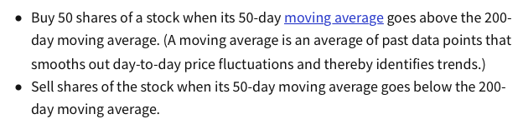

Reference:

* [Basics of Algorithmic Trading: Concepts and Examples](https://www.investopedia.com/articles/active-trading/101014/basics-algorithmic-trading-concepts-and-examples.asp)
* [7 Best ETF Trading Strategies for Beginners](https://www.investopedia.com/articles/investing/090115/7-best-etf-trading-strategies-beginners.asp)
* [Dual Moving Average Crossover](https://www.youtube.com/watch?v=SEQbb8w7VTw)

VWAP(Volume weighted Average price) + V-EMA (Volume weighted exponential moving average)

Using VWAP and V-EMA to price shares is probably more useful than just using simple moving averages because it takes into account the volume of shares being traded

<https://empirica.io/blog/vwap-algorithm/>

<https://www.cis.upenn.edu/~mkearns/papers/vwap.pdf>

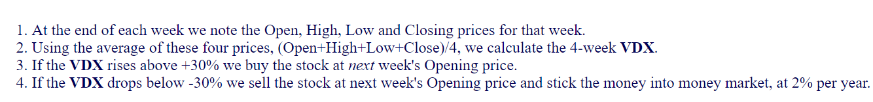

<https://www.financialwisdomforum.org/gummy-stuff/EMA.htm>